# CPT_Logo_Manual.jpg SharePoint Social Networking

**Lab Time**: 60 minutes

**Lab Overview:** In this lab you will utilize some of the social network features in SharePoint 2010. You will read, comment on, populate and manage a blog site. You will also contribute to a wiki site and learn to link wiki pages together.

## Exercise 1: Using a SharePoint Blog

In this exercise you will comment on and populate an existing blog site in SharePoint. You will also organize posts and moderate an existing blog.

1. Log into your site collection using the account **Janice Galvin**.
2. Using Internet Explorer, browse to the URL of the SharePoint site collection you were provided to use when working on the hands on labs in this course.
3. When prompted to login, enter [[AD-DOMAIN]]\janice in the **User Name** field and click **OK**. Use the password specified in the *Hands-On Lab Overview* document provided in the student manual.

**Note**: If you are not prompted to login & if you are logged in as another user, use the Welcome Menu to logout and login as a different user.

1. Navigate to the Wingtip Blog site:
2. From the Wingtip Team Site, select **Wingtip Blog** Top Navigation Bar.
3. Read the existing posts on the blog and comment on the recent post detailing the purpose of the blog.
4. Click the **Comments** link under the post by Ken:

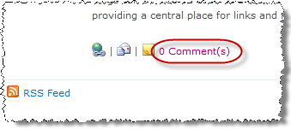

1. Enter a **Title** and **Body** and click **Submit Comment:**

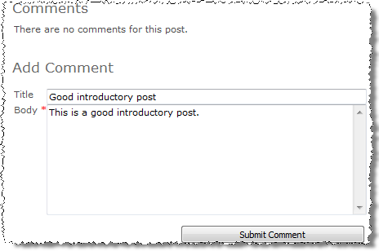

1. Verify that the number of **Comments** on Ken’s post increased from **0** to **1** and verify Janice’s comment appears as well.
2. Add a post to the blog as Janice Galvin:
3. Click the **Create a Post** link under **Blog Tools** in the upper right area of the page.

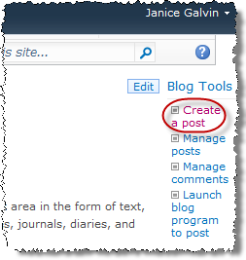

1. In the resulting **Posts - New Item** dialog box, notice the informational message above the entry fields warning that all posts are subject to approval before appearing on the site.
2. Enter the following and click **Save as Draft**:

**Title:** Manager Suggestions

**Body:** I think it would be a great idea to start a suggestion box for managers. Each department manager could make suggestions about tactics and practices they have found work well in their department for promoting employee recognition, productivity and harmony.

**Category:** <none>

**Published:** {current date and time}

1. Verify that the new post does not appear on the home page of the blog for the author or any visitors.
2. Notice that upon completing Janice's entry, the post does not appear on the blog site's home page for Janice (even though she wrote it).
3. Authenticate to the blog as Michael Sullivan, a member of the Wingtip Blog Visitors SharePoint Group that has been granted the Read permission level to this site using the **Welcome Menu** top right corner and select **Sign in as Different User** and entering **[[AD-DOMAIN]\michael** for the user name.
4. Notice that Janice’s post does not appear for Michael either.
5. Approve Janice’s new post as the moderator, Ken Sanchez.
6. Authenticate into the library as Ken Sanchez using the **Welcome Menu** in the top right corner and select **Sign in as Different User** and enter [[AD-DOMAIN]]\ken for the user name and click **OK**.
7. Click on the **All Site Content** link in the Quick Launch Bar.
8. Click on the link for the **Posts** list under the **Lists** heading.
9. Note that the value in the **Approval Status** column for Janice’s recent post is **Pending**. Ken can see the pending item because he has been granted the permission to approve items on this blog site.

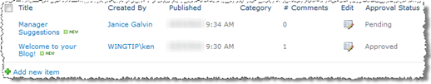

1. Check the selection box for the Janice’s new post and begin the approval process by clicking on the **Approve/Reject** button in the **Workflows** group of the **Items** tab in the ribbon.
2. In the resulting **Approve/Reject** dialog box, select the **Approved** radio button and enter a comment indicating Ken likes Janice’s post.
3. Click **OK** to complete the approval and notice that in the list the item's **Approval Status** column value has changed from **Pending** to **Approved**.
4. Verify Janice’s approved post now appears for Janice and other visitors to the blog site.
5. Authenticate into the library as Janice Galvin using the **Welcome Menu** in the top right corner and select **Sign in as Different User** and enter [[AD-DOMAIN]]\janice for the user name and click **OK**.
6. Verify that Janice now sees her **Manager Suggestion** post on the home page of the blog site.
7. Authenticate into the library as Michael Sullivan using the **Welcome Menu** in the top right corner and select **Sign in as Different User** and enter [[AD-DOMAIN]]\michael for the user name and click **OK**.
8. Verify that Michael can also now see Janice’s **Manager Suggestion** post on the home page of the blog site.

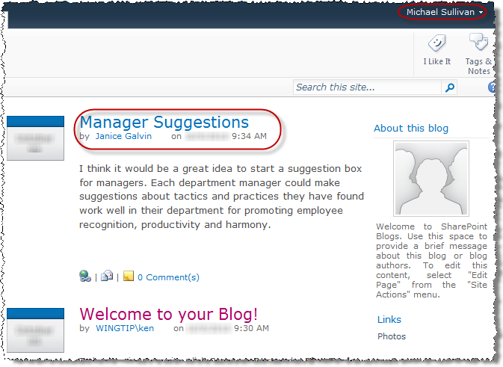

1. Customize the Category names available on the blog site as the site moderator:
2. Authenticate into the library as Ken Sanchez using the **Welcome Menu** in the top right corner and select **Sign in as Different User** and enter [[AD-DOMAIN]]\ken for the user name and click **OK**.
3. Click on the **All Site Content** link in the Quick Launch Bar.
4. Click on the link for the **Categories** list under the **Lists** heading.
5. Use the **Edit** icon on each **Category** item one at a time to change their **Title** as follows:

**Category 1 »** Ideas

**Category 2 »** Important Notices

**Category 3 »** Fun Stuff

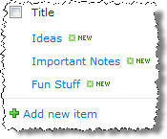

1. Customize the Category names available on the blog site as a contributor:
2. Authenticate into the library as Janice Galvin using the **Welcome Menu** in the top right corner and select **Sign in as Different User** and enter [[AD-DOMAIN]]\janice for the user name and click **OK**.
3. Click the **Add new category** hyperlink under the **Categories** in the Quick Launch Bar and add a 4th category with a **Title** of **Motivation**.
4. Change Janice’s earlier Manager Suggestion post from having no category to being in an appropriate category:
5. Navigate to the **Wingtip Blog** home page.
6. Click the title of the **Manager Suggestions** post.
7. Click on the **Edit** button to the right of the post title near the **Blog Tools** menu.



1. Alter the **Category** property by highlighting the **Fun Stuff** category in the left side list and clicking the **Add»** button to place the category into the right side list. Click **Save as Draft** to complete the edit.

**Note:** More than one category can be assigned to a single post if necessary.

1. Reject the new Category change to Janice’s Manager Suggestions post as the moderator, Ken Sanchez:
2. Authenticate into the library as Ken Sanchez using the **Welcome Menu** in the top right corner and select **Sign in as Different User** and enter [[AD-DOMAIN]]\ken for the user name and click **OK**.
3. Click on the **All Site Content** link in the Quick Launch Bar.
4. Click on the link for the **Posts** list under the **Lists** heading.
5. Note that the value in the **Approval Status** column for Janice’s recent post is **Pending**.
6. Ken can see the pending item because he has been granted the permission to approve items on this blog site.
7. Check the selection box for the Janice’s **Manager Suggestion** post and begin the approval process by clicking on the **Approve/Reject** button in the **Workflows** group of the **Items** tab in the ribbon.
8. In the resultant **Approve/Reject** dialog box, select the **Rejected** radio button and enter a comment indicating Ken thinks **Fun Stuff** is an inappropriate category for Janice’s post. Click **OK** to complete the rejection and notice that in the list the item's **Approval Status** column value has changed from **Pending** to **Rejected**.

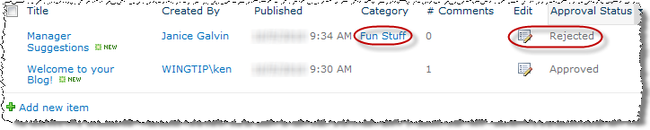

1. Navigate back to the home page of the blog site via your preferred method.
2. Notice that the entire **Manager Suggestions** post does not appear on the home page for Ken.
3. Correct the category on Manager Suggestions to the Ideas category as Janice Galvin:
4. Authenticate to the blog as Janice Galvin using the **Welcome Menu** top right corner and select **Sign in as Different User** and entering **[[AD-DOMAIN]\janice** for the user name.
5. Click on the **All Site Content** link in the Quick Launch Bar.
6. Click on the link for the **Posts** list under the **Lists** heading.
7. Note that the value in the **Approval Status** column for **Manager Suggestions** is still **Rejected**. Janice can see the rejected item because he is the author.
8. Use the **Edit** icon on the **Manager Suggestions** post item to change its values:

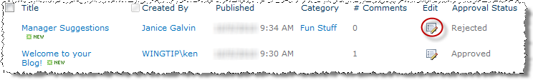

1. Alter the **Category** property by highlighting the **Fun Stuff** category in the right side list and clicking the **<Remove** button to place the category into the left side list.
2. Now highlight the **Ideas** category in the left side list and click the **Add>** button to place the Category into the right side list. Click **Save as Draft** to complete the edit.
3. Approve Janice’s new category value on Manager Suggestions as the moderator, Ken.
4. Authenticate into the library as Ken Sanchez using the **Welcome Menu** in the top right corner and select **Sign in as Different User** and enter [[AD-DOMAIN]]\ken for the user name and click **OK**.
5. Click on the **All Site Content** link in the Quick Launch Bar.
6. Click on the link for the **Posts** list under the **Lists** heading.
7. Note that the value in the **Approval Status** column for Janice’s **Manager Suggestions** post is **Pending**. Ken can see the pending item because he has been granted the permission to approve items on this blog site.
8. Check the checkbox box for the Janice’s **Manager Suggestions** post and begin the approval process by clicking on the **Approve/Reject** button in the **Workflows** group of the **Items** tab in the ribbon.
9. In the resulting **Approve/Reject** dialog box, select the **Approved** radio button and enter a comment indicating Ken approves of the new category. Click **OK** to complete the approval and notice that in the list the item's **Approval Status** column value has changed from **Pending** to **Approved**.
10. Navigate back to the home page of the blog site via your preferred method.

**Note:** The remaining steps in this exercise are can only be performed if you have Microsoft Word 2010 installed.

1. Create a new post as Ken Sanchez using a non-SharePoint blog editor.
2. Still logged onto the blog site as Ken Sanzchez from the previous step, click on the **Launch blog program to post** link under **Blog Tools** on the right. The default blog editing application registered in the Windows OS will automatically launch. If you have Word 2007 or Word 2010 installed it will open.
3. Verify that the **URL** to the **Wingtip Blog** site automatically appears in the **Blog URL** field of the **New SharePoint Blog Account** pop-up prompt and click **OK**.
4. Click **Yes** in the Microsoft Word pop-up prompt regarding data being sent from Word to the Blog provider.
5. After a brief pop-up registering to the blog provider, click **Yes** again in another Microsoft Word 2010 pop-up prompt regarding data being sent from Word to the Blog provider.
6. Click **OK** to the **Account registration successful** message.
7. Click on the **[Enter Post Title Here]** text to replace it with the following Title: **A Bit about Dogs.**
8. Click the white space beneath the horizontal divider line under the title and type a short entry regarding what you like about dogs. Include some **Word Art** from the **Insert** tab in the ribbon.

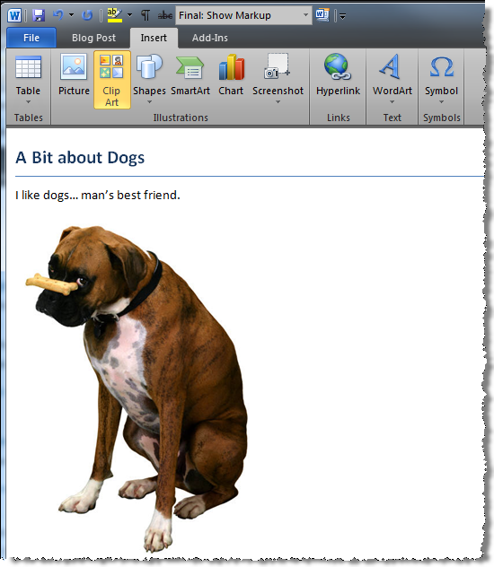

1. Click on the **Insert Category** button in the **Blog** group of the **Blog Post** tab in the ribbon.
2. Use the resulting drop down box that appears at the top of the body section in the edit window to select the **Fun Stuff** category for this new post.

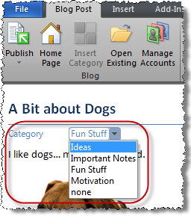

1. Complete the new post by clicking the **Publish** button in the **Blog Post** tab in the ribbon.

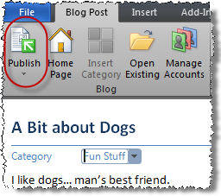

1. Click **Yes** in the Microsoft Word pop-up prompt regarding data being sent from Word to the Blog provider.
2. Note the information panel stating the blog post has been published.

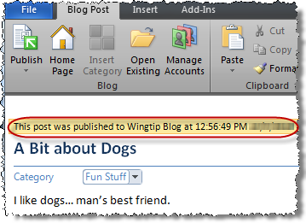

1. Exit Microsoft Word (*click Don't Save if prompted*).
2. Verify the new post appears on the Wingtip Blog site:
3. Verify that Ken Sanchez’s new post about dogs appears at the top of the home page (you may need to refresh the browser):

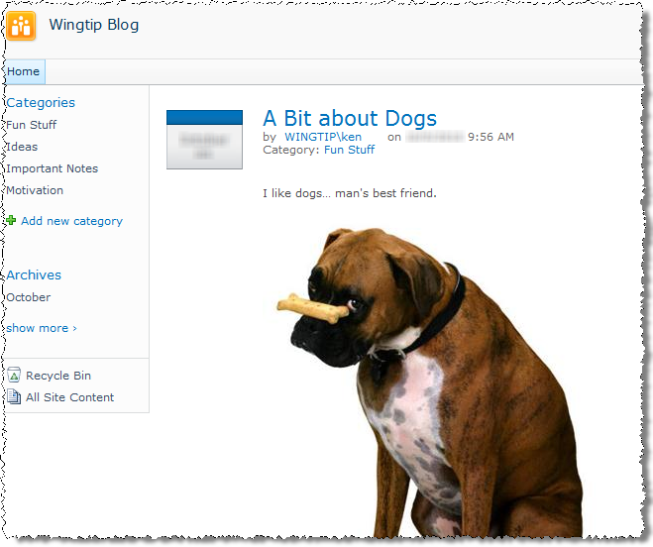

1. Edit an existing post using a non-SharePoint editor:
2. Still logged onto the blog site as Ken Sanchez from the previous step, click on the **Launch blog program to post** link under **Blog Tools** on the right to again launch the default blog editing application, Microsoft Word.
3. Click on the **Open Existing** button from the **Blog** group of the **Blog Post** tab in the ribbon.

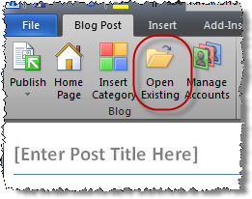

1. Click **Yes** in the Microsoft Word pop-up prompt regarding data being sent from Word to the Blog provider.
2. From the resulting **Open Existing Post** dialog box, verify that the **Account** field represents the Wingtip Blog account and select the post recently added in the previous steps called **A Bit about Dogs** by single-clicking on it to highlight it then clicking **OK**.
3. Click **Yes** again in another Microsoft Word pop-up prompt regarding data being sent from Word to the Blog provider.
4. Insert a picture into the post using the **Insert** tab’s **Picture** button in the ribbon. Add any image from your workstation.
5. Re-publish the edited post by clicking the **Publish** button in the Blog section of the Blog Post ribbon.
6. Click **Yes** in the Microsoft Word pop-up prompt regarding data being sent from Word to the Blog provider.
7. Go back to the browser and verify that Ken’s edit to the **A Bit about Dogs** post about dogs appears at the top of the home page (you may need to refresh the browser).

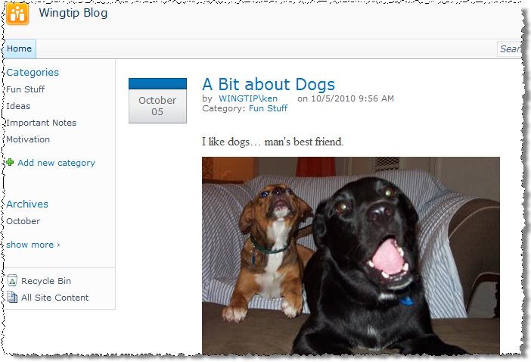

In this exercise you practiced posting to, organizing, and moderating a SharePoint blog.

## Exercise 2: Using a SharePoint Wiki

In this exercise you will contribute to an existing wiki library in SharePoint. You will learn to link related pages and organize wiki information.

1. Navigate to the Wingtip Knowledge Base site as Ken Sanchez, a member of the Wingtip Team Site Members SharePoint Group that has been granted the Contribute and Approve permission levels to the site:
2. Authenticate into the library as Ken Sanchez using the **Welcome Menu** in the top right corner and select **Sign in as Different User** and enter [[AD-DOMAIN]]\ken for the user name and click **OK**.
3. Select **Knowledge Base** from the Top Navigation Bar:

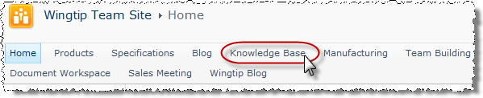

1. Read the included help on using SharePoint Wikis:
2. Click the **Site Pages** link in the Quick Launch Bar.
3. Select the item **How To Use This Library** from the Site Pages library.
4. After reading the tutorial page and learning tricks for populating a wiki, return to the home page by clicking the site title **Knowledge Base** in the breadcrumb at the top of the page.
5. Change the layout of the Products wiki page and add a picture to the header:
6. Click on the **Products** hyperlink in the **Areas of Interest** section in the upper right corner of the home page.

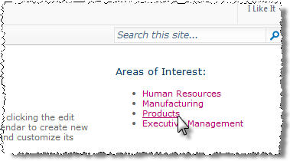

1. Prepare the page for editing by checking it out of the **Site Pages** library using the **Check Out** button in the **Edit** group of the **Page** tab in the ribbon. This will prevent other wiki contributors from concurrently editing the Products page in a different manner and potentially overwriting your work.

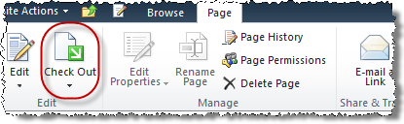

1. Now that the page is checked out to Ken, click the **Edit** button from the same **Edit** group of the **Page** tab in the ribbon to put the page into Edit mode. The **Editing Tools** contextual tab group will appear at the top of the page.
2. Change the layout of the page by clicking the **Text Layout** button in the **Layout** group of the **Format Text** tab in the ribbon. Select **Two columns with header**.

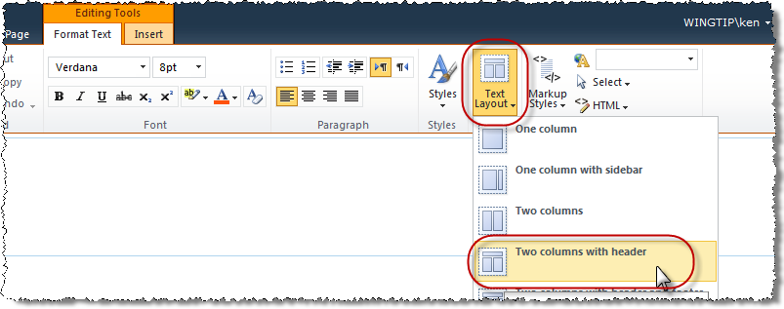

1. Type **Products** in the header section then use your imagination to add some content to the Products page.
2. Single-click the cursor to position it at the end of the word **Products** and hit [ENTER] to begin a new line in the header. Click the **Picture** button in the **Media** group in the **Insert** tab in the ribbon and choose **From Computer**:

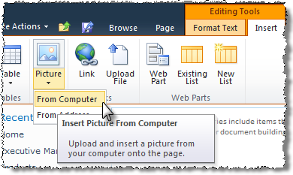

1. In the resulting **Select Picture** dialog, use the **Browse** button to select any picture on your workstation and click **Open**.
2. Back in the **Select Picture** dialog, leave the **Upload To:** value as **Site Assets** and the **Overwrite** checkbox selected, then click **OK**.
3. Position or resize the new picture as you wish.
4. Add content to the left and right sections of the Products page layout:
5. Single-click the cursor to position it at the beginning of the first available line in the left column section of the page layout. Enter the following paragraph:

**Welcome to the Products Wiki! Here you will find helpful links to information about the Products team and how we do things. Simply click on any of the links you find interesting to the right to begin your journey through our knowledgebase. If you need additional assistance or cannot find what you're looking for, please contact Mike Thomas, the Products Team Manager.**

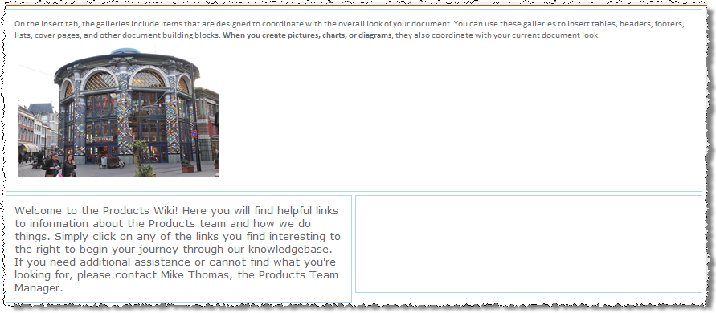

1. Single-click the cursor to position it at the beginning of the first available line in the right column section of the page layout. Enter the following text: **[[Product Categories]]** then press [ENTER] to begin a new line before adding the remaining text (each on their own line, disregard message that destination pages do not exist):

**[[Product Safety Sheets]]**

**[[New Products]]**

**[[Meet the Products Team]]**

From the **Editing Tools » Format Text** tab in the ribbon, click on the **Save & Close** button to save all page edits.

1. View the Products page Janice Galvin:
2. Authenticate to the blog as Janice Galvin using the **Welcome Menu** top right corner and select **Sign in as Different User** and entering **[[AD-DOMAIN]\janice** for the user name.
3. Note that the recent additions to the **Products** page do not appear for Janice. Notice also the banner informational message stating the page is being edited and is checked out to Ken.

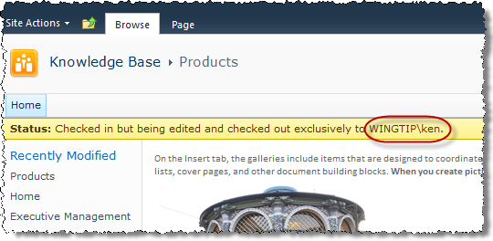

1. Login and checkin the checked out files as Ken Sanchez:
2. Authenticate to the blog as Ken Sanchez using the **Welcome Menu** top right corner and select **Sign in as Different User** and entering [[AD-DOMAIN]\ken for the user name.
3. Click the **Check-In** button in the **Page** tab in the ribbon to check Ken’s work on the Products page back into the Site Pages library.
4. Add comments and click **OK** to the **Check In** dialog.
5. View the Products page Janice Galvin:
6. Authenticate to the blog as Janice Galvin using the **Welcome Menu** top right corner and select **Sign in as Different User** and entering [[AD-DOMAIN]\janice for the user name.
7. Notice that all additions to the **Products** page now appear for Janice. However the page links in the right section are underlined in dashed lines, indicating they are not yet valid pages. (DO NOT click on any of them yet!)
8. Click on the page links to generate the destination wiki pages.
9. Authenticate to the blog as Ken Sanchez using the **Welcome Menu** top right corner and select **Sign in as Different User** and entering [[AD-DOMAIN]\ken for the user name.
10. Single-click on the first page link entitled **Product Categories** and note the information in the **New Page** dialog that indicates a new wiki page will be created into the Site Pages library.

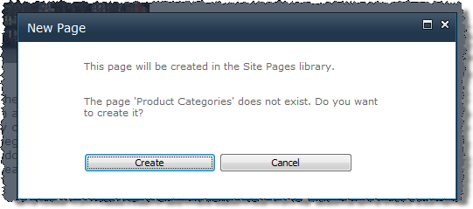

1. Click **Create**.
2. Use your recently acquired skills to populate the new **Product Categories** page with some text, then **Save & Close** in the ribbon the page.
3. Navigate back to the **Products** wiki page wiki page via your preferred method.

**Note:** A link to the Products wiki page appears under the **Recently Modified** header in the Quick Launch Bar.

1. Repeat the above steps to generate the remaining new wiki pages: **Product Safety Sheets**, **New Products** and **Meet the Products Team**.
2. Use the Navigate Up button to return to the Wingtip Team Site.

In this exercise you practiced using a SharePoint wiki.